Hysteresis Oscillators

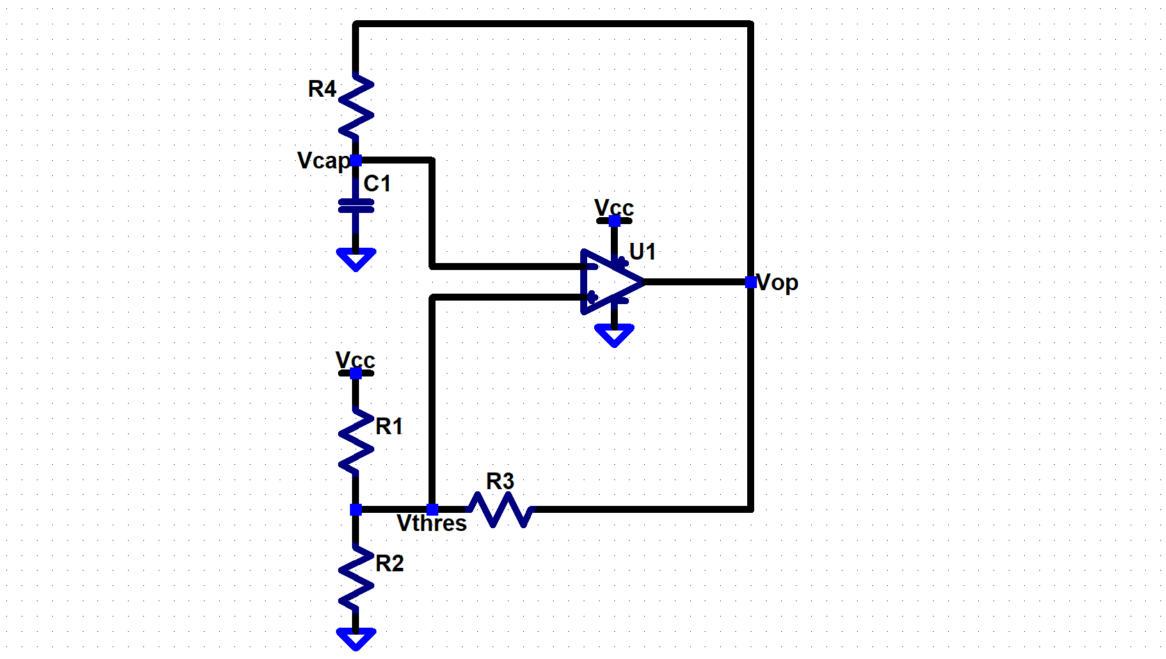

Figure 1: Hysteresis Oscillator Circuit

# Summary

The Hysteresis oscillator, also known as a Schmitt Trigger oscillator, is a type of comparator based relaxation oscillator. The circuit uses an operational amplifier as a comparator. , , and are used to provide hysteresis, positive feedback, which is creates a comparator trigger point that varies with the voltage output of the opamp, . The RC circuit, and , charges or discharges, up to or down to the current trigger point, which is set by . Ultimately, this circuit can produce a square wave output with a frequency set by the RC circuit and comparator trigger points.

# Hysteresis Resistors

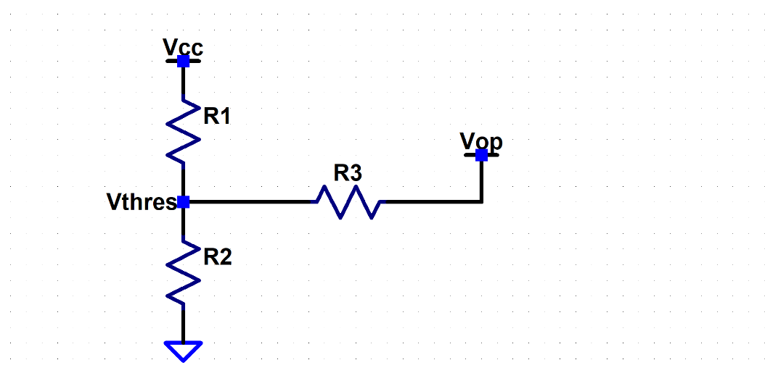

Figure 2: Hysteresis Resistors

## Generalized Equation

Using nodal analysis a generalized equation for , the threshold voltage for triggering the comparator response of the hysteresis oscillator, can be found.

Equation 1: General Equation for Hysteresis caused threshold Voltage Values

Where will have a high and low voltage state, producing a and .

## Particular Solutions for the Generalized Equation

To make evaluating a specific set of resistance values, , , and easier a particular solution to the generalized equation can be implemented.

### R1, R2 and R3 set to be equal

One particular solution can be arrived at by setting , and to be equal to :

Equation 2: Particular Solution setting ==

This equation can be further simplified by assuming a set of ideal output states from the opamp[1].

|  |  |
| --- | --- |
| *Ideal Low State* | *Ideal High State* |
|  |  |

*Equation 3: Ideal Low State threshold voltage in proportion to , given*

Equation 4: Ideal High State threshold voltage in proportion to , given

Setting the hysteresis resistors to be equal results in a set of threshold voltage points which are for the lower threshold and for the high threshold.

### R1 and R2 set to be equal

Another particular solution can be arrived at by setting and to be equal to , and setting to be some factor of , times :

Equation 5: Particular Solution setting and

This equation can be further simplified by assuming a set of ideal output states from the opamp.

|  |  |
| --- | --- |
| *Ideal Low State* | *Ideal High State* |
|  |  |

*Equation 6: Ideal Low State threshold voltage in proportion to , given*  and

*Equation 7: Ideal High State threshold voltage in proportion to , given*  and

Simplifying down to this set of equations allows a few assumptions about how adjusting in relation to , affects the threshold voltages of this resistor configuration.

#### Large in Relation to

If is very large in comparison to , this would require to also be very large, which allows us to take the limit of x, from Equation 6 and Equation 7, as it approaches infinity to evaluate for very large values of :

Taking the limit as approaches infinity shows that when and the high and low threshold voltages approach roughly .

#### Small in Relation to

If, though, is much smaller than , meaning x is also very small:

Taking the limit as x approaches zero shows that when and the high and low threshold voltages approach and .

#### Equal to

If is set equal to , meaning :

This result was shown in the above section.

#### Equal to Center Point

One more insight which can be seen from the simplified equations is: e simplified equations is"

This effectively means that the threshold values will be center balanced with at the center of the threshold points.

#### Equal to Threshold Voltage Span vs Value

Taking the difference between and gives us an equation for the span of the threshold voltages as a proportion of :

Graphing the difference function provides insight into how the threshold voltage span, in relation to , changes with different values of .

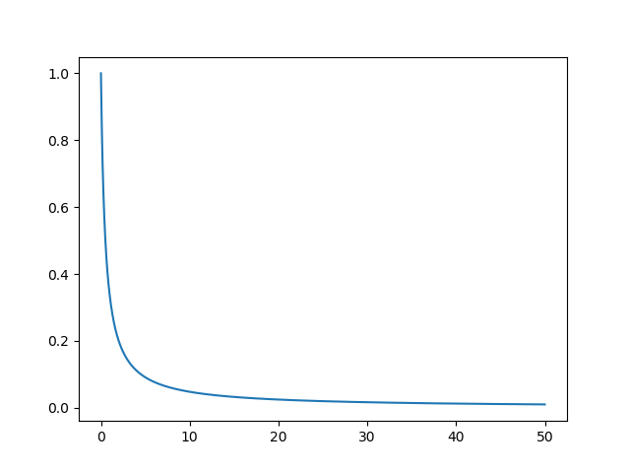

Figure 3: Graph of Threshold Voltage span when up to equal to 50

#### EX:

With find which gives a and a .

### R1 and R3 set to be equal

Another particular solution can be arrived at by setting and to be equal to , and setting to be some factor of , times :

Equation 8: Particular Solution setting and

This equation can be further simplified by assuming a set of ideal output states from the opamp.

|  |  |
| --- | --- |
| *Ideal Low State* | *Ideal High State* |
|  |  |

*Equation 9: Ideal Low State threshold voltage in proportion to , given*  and

*Equation 10: Ideal High State threshold voltage in proportion to , given*  and

Simplifying down to this set of equations allows for assumptions to be made about how adjusting in relation to , affects the threshold voltages of this resistor configuration.

#### Large in Relation to

If is very large in comparison to , this would require to also be very large, which allows us to take the limit of x, from Equation 9 and Equation 10, as it approaches infinity to evaluate for very large values of :

Taking the limit as approaches infinity shows that when and the high voltage threshold approaches and the low threshold approaches .

#### Small in Relation to

If, though, is much smaller than , meaning x is also very small:

Taking the limit as x approaches zero shows that when and the high and low threshold voltages approach . This makes sense because is attached to ground. Making smaller would push the potential at closer to ground and making exactly would cause to effectively be shorted to ground.

#### Equal to

If is set equal to , meaning :

This result was also shown in a previous section above.

#### Equal to Threshold Voltage Span vs Value

Taking the difference between and gives us an equation for the span of the threshold voltages as a proportion of : e simplified equations is"

Graphing the difference function provides insight into how the threshold voltage span, in relation to , changes with different values of .

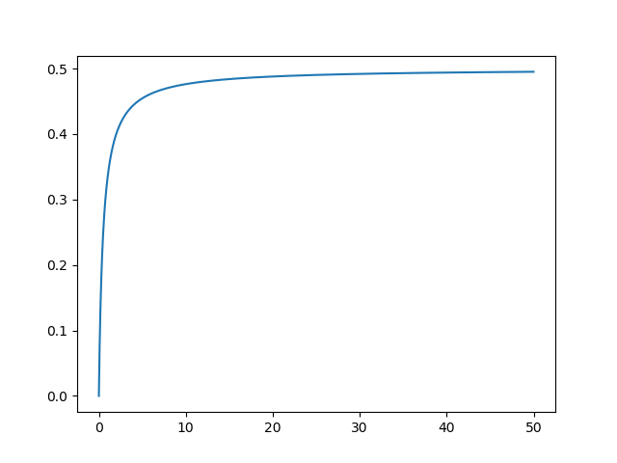

Figure 4: Graph of Threshold Voltage span when up to equal to 50

#### EX:

With find and which give a .

### R2 and R3 set to be equal

Another particular solution can be arrived at by setting and to be equal to , and setting to be some factor of , times :

Equation 8: Particular Solution setting and

This equation can be further simplified by assuming a set of ideal output states from the opamp.

|  |  |
| --- | --- |
| *Ideal Low State* | *Ideal High State* |
|  |  |

*Equation 12: Ideal Low State threshold voltage in proportion to , given*  and

*Equation 13: Ideal High State threshold voltage in proportion to , given*  and

Simplifying down to this set of equations allows for assumptions to be made about how adjusting in relation to , affects the threshold voltages of this resistor configuration.

#### Large in Relation to

If is very large in comparison to , this would require to also be very large, which allows us to take the limit of x, from Equation 12 and Equation 13, as it approaches infinity to evaluate for very large values of :

Taking the limit as approaches infinity shows that when and the high voltage threshold approaches and the low threshold approaches 0.

#### Small in Relation to

If, though, is much smaller than , meaning x is also very small:

Taking the limit as x approaches zero shows that when and the high and low threshold voltages approach . This makes sense because is attached to . Making smaller would push the potential at closer to and making exactly would cause to effectively be shorted to .

#### Equal to

If is set equal to , meaning :

This result was also shown in a previous section.

#### Equal to Threshold Voltage Span vs Value

Taking the difference between and gives us an equation for the span of the threshold voltages as a proportion of : e simplified equations is"

This function is the same as it was in the case. Graphing the difference function provides insight into how the threshold voltage span, in relation to , changes with different values of .



Figure 4: Graph of Threshold Voltage span when up to equal to 50

#### EX:

With find and which give a .

# RC Circuit Timing

1. This is not actually the case, as an opamp when acting as a comparator outputting its high state will generally approach but will fall short of , this is likewise for the low state of the opamp comparator, it will approach ground, 0V, but fall short of it.